**MGRS Mapper**

**Data Visualisation | 23.09.2023**

# Executive Summary

MGRS Mapper is a web-based tool that allows users to create and share custom operational overlays using the Military Grid Reference System (MGRS). MGRS Mapper is a valuable tool for military personnel, law enforcement, and other professionals who need to create and share maps that use the MGRS coordinate system.

This tool report provides a comprehensive overview of the installation, execution, scope, and limitations of the MGRS Mapper tool. The report also includes recommendations for how to use the tool effectively.

# Index

**Executive Summary 2**

**Index 2**

**1. Introduction 2**

**2. Tool Details 2**

**3. Installation 3**

**4. Execution 3**

**5. Scope and Limitations 3**

**6. Conclusion 3**

**7. References (if any) 4**

# Introduction

MGRS Mapper is a web-based tool that allows users to create and share custom operational overlays using the Military Grid Reference System (MGRS). MGRS is a coordinate system that is used by the military and other organizations to identify locations on the ground. MGRS coordinates are composed of a grid zone identifier, a 100,000-meter square identifier, and a 10,000-meter square identifier.

MGRS Mapper allows users to create custom overlays that can be used to mark locations, draw lines and shapes, and add text and symbols. MGRS Mapper also allows users to share their overlays with others by generating a link or embedding the overlay in a website.

# Tool Details

MGRS Mapper is a web-based tool, so there is no need to install any software. To use the tool, simply visit the MGRS Mapper website and create an account.

# Installation

**Web based tool.  
https://mgrs-mapper.com/**

# Execution

To use the MGRS Mapper tool, simply create a new overlay and start adding features. You can add features by clicking on the corresponding icon in the toolbar or by using the keyboard shortcuts.

Once you have added all of the features that you want to your overlay, you can save it and share it with others. To save your overlay, click on the "Save" button. To share your overlay, click on the "Share" button and select the desired sharing option.

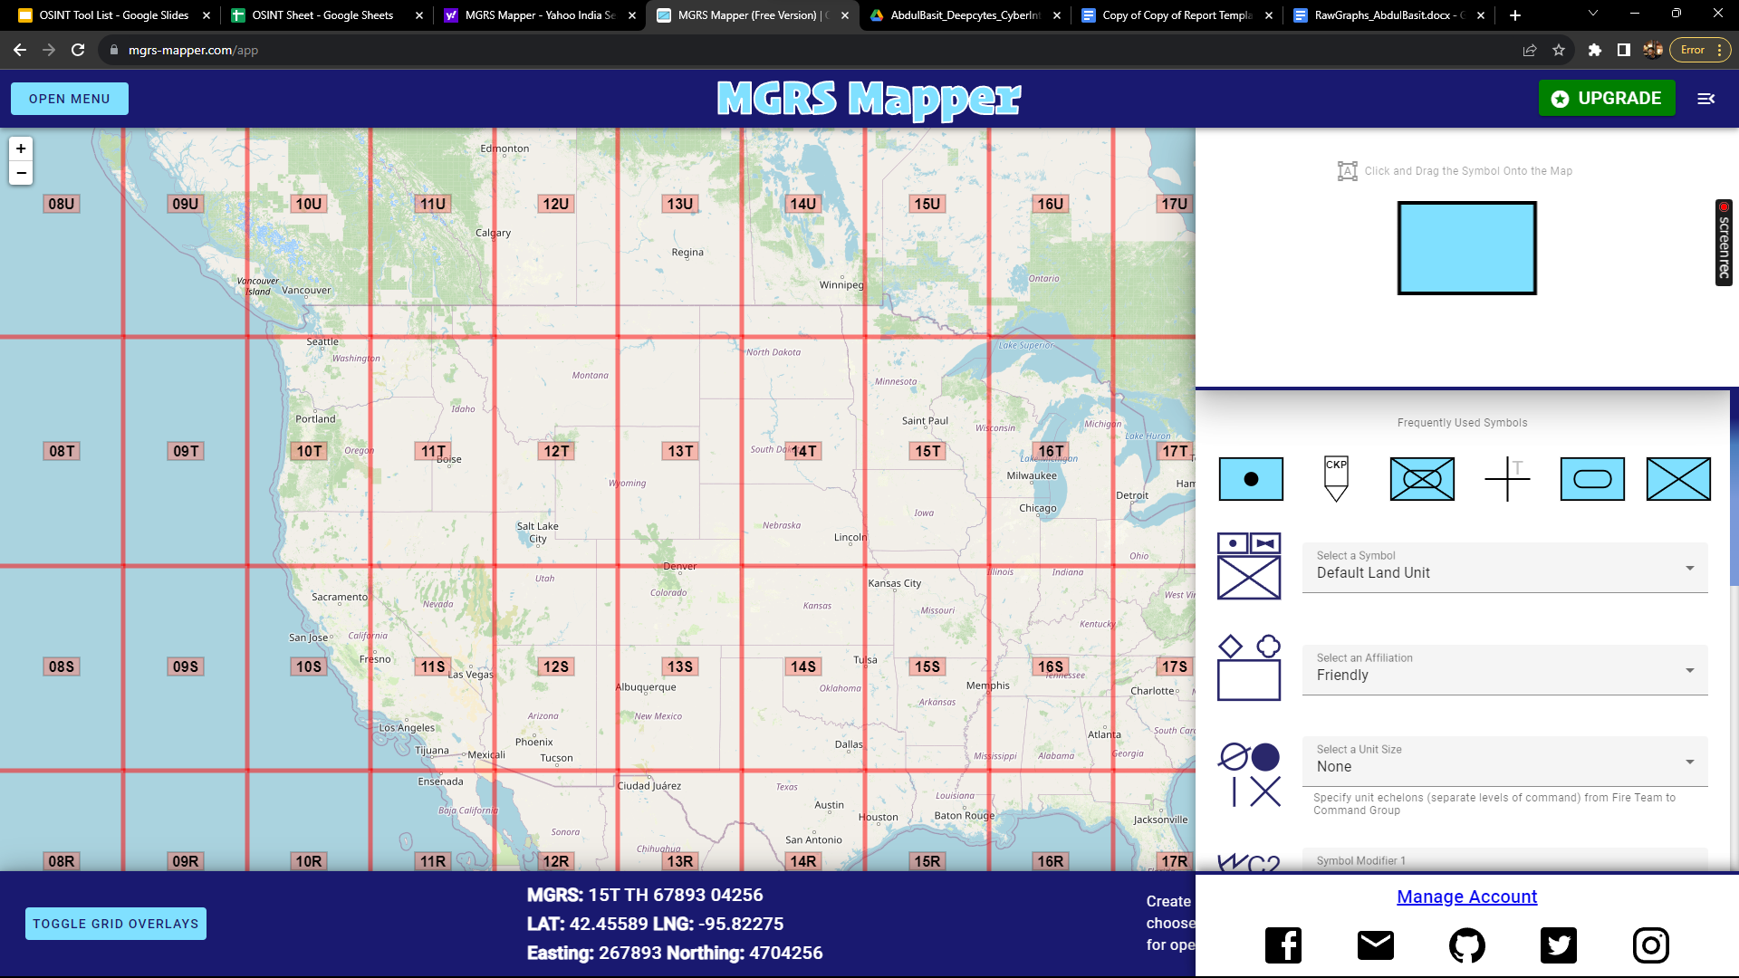

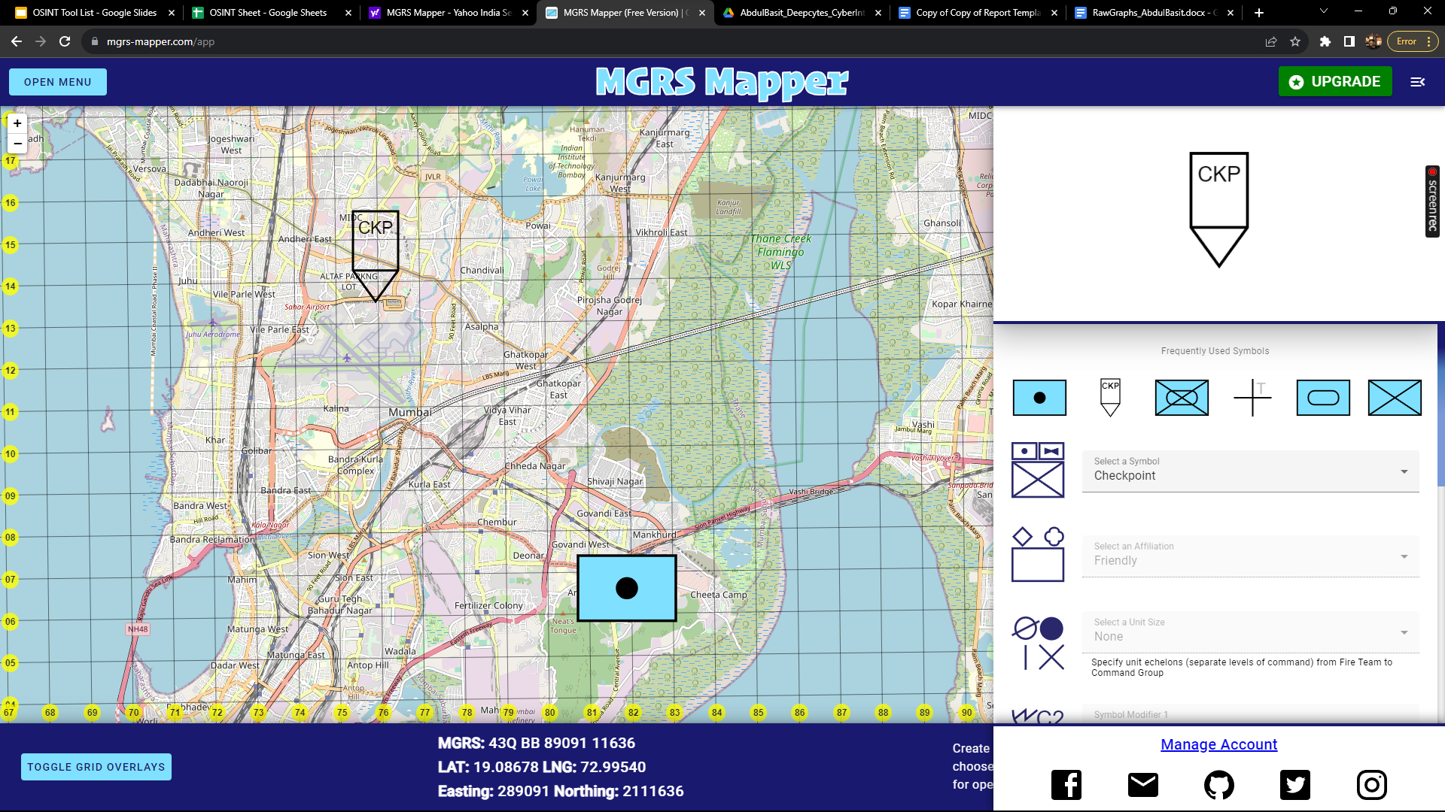

# Scope and Limitations

MGRS Mapper is a powerful tool for creating and sharing custom operational overlays using the MGRS coordinate system. However, it is important to be aware of the limitations of the tool.

MGRS Mapper is not a GIS tool. It does not provide the same level of functionality as a GIS tool, such as the ability to edit feature attributes or perform spatial analysis.

Additionally, MGRS Mapper is only compatible with the MGRS coordinate system. It does not support other coordinate systems, such as UTM or latitude and longitude.

# Conclusion

MGRS Mapper is a valuable tool for military personnel, law enforcement, and other professionals who need to create and share maps that use the MGRS coordinate system. The tool is easy to use and provides a variety of useful features. However, it is important to be aware of the limitations of the tool before using it.

Recommendations

To use the MGRS Mapper tool effectively, it is important to understand its limitations. For example, MGRS Mapper is not a GIS tool and it is only compatible with the MGRS coordinate system.

It is also important to use MGRS Mapper in conjunction with other tools and services. For example, you could use MGRS Mapper to create a custom operational overlay, and then use a different tool to edit the feature attributes or perform spatial analysis.

Additionally, it is important to review the documentation for MGRS Mapper before using the tool. This will help you to understand the features of the tool and how to use it effectively.

Overall, the MGRS Mapper tool is a valuable resource for military personnel, law enforcement, and other professionals who need to create and share maps that use the MGRS coordinate system.